

**CSE 105: Structured programming**

**Section: x, Fall-2017**

|  |
| --- |
| A Project Report  on  **Murder On The Orient Express** |
| Submitted by:  Group: 7  Group Members:  AMIT ROY 2017-3-60-021  MD. MOKIBUL HASAN ANTOR 2017-3-60-019  SHEKHOR CHANDRA SAHA 2017-3-60-025 |
| Submitted to:  Sadia Nowrin  Lecturer, Dept. of CSE |
| Date of Submission:10-12-2017 |

**DEPARTMENT OF COMPUTER SCIENCE & ENGINEERING**

**EAST WEST UNIVERSITY**

1. **Problem Statement**

Detective Hercule Poirot was travelling to London via a three days trip on Orient Express .On the second day,Poirot found out that a passenger had been murdered and the murderer is hidden somewhere in the train. He planned to investigate all the room secretly. There were ***n*** numbers of rooms in the train numbered from **1** to ***n***. Each room can be unlocked by entering a secret number in the lock, If room number is n, it can be unlock by nth prime number and again locked with sum of n and nth prime number. For example, Room **5** can be entering **11** and locked by entering **16**. Here, **11** is the $5^{th}$ prime number and **16** is the sum of **5** and **11**.

.

**2. System Requirements**

The system on which the project is implemented has the following properties:

Processor: Intel Core i7,3.60 GHz

RAM: 8.00 GB

Operating System: Windows 10, 64-bit

IDE (Integrated Development Environment): Code-Blocks

**3. System Design**

In this section, the algorithm of the project is described as below:

* 1. Send a input in void function from main function
* 2. Play a infinity loop.
  + 2.1: Scan a number as input.
* 3. If number is not equal to 0
  + 3.1: If numbem(num) is less then equal 100
    - 3.1.1: Loop from i=2 to less then equal 10000
      * 3.1.1.1: If count not equal to num
        + 3.1.1.1.1: Play a loop from j=2 to less then equal j

3.1.1.1.1.1: If i and j are equal

3.1.1.1.1.1.1: Add 1 to Count and store it in count.

3.1.1.1.1.1.2: Srore i in un.

3.1.1.1.1.2: If else i mod j equal to 0

3.1.1.1.1.2.1: Break.

* + - 3.1.2: Count equal to 0
    - 3.1.3: Print Unlock with: (Value of un)
    - 3.1.4: Print Lock with: (Sum of num and un)
  + 3.2: Else
    - 3.2.1: Print Room does not exist.

**4. Implementation**

In this section, important parts of the source code are explained.

* 1. **Main function:**

*int main()*

{

int *input*;

printf("\t\t\tMURDER ON THE ORIENT EXPRESS\n");

printf("-----------------------------------------------------------------------\n");

function(*input*); *//Send input in a function*

return 0;

}

* 1. **Taking input:**

*void function(x)* //Receive input in void type function

{

int *num*,*i*,*j*,*un*,*count*=0; *//Declare integer*

for( ; ; ) *//Infinity Loop*

{

printf("Enter Room Number: ");

scanf("%d",&*num*); *//Take a number as a input*

printf("\n");

**4.3 Condition:**

if(*i*==*j*) *// If condition*

{

*count*=*count*+1; *// Counter*

*un*=*i*; *//Store i in un.*

}

else if(*i*%*j*==0)

{

break; *//Break statement*

}

**4.4 Print:**

printf("Unlock with: %d",un); *//Print un* .

printf("\t\t\tLock with: %d\n",num+un);  *//Print sum of num and un*

**5. Testing Results**

In this section, some sample input-outputs are explained with appropriate screenshot.

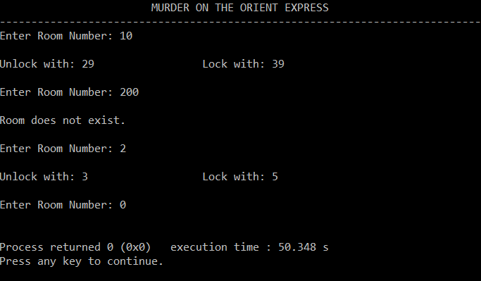

**5.1 Testcase 1:**

Here the input “10”. ${10}^{th}$ prime number is 29. So, unlock with 29 and lock with 39(29+10).

**5.2 Testcase 2:**

Here the input is “200”. Since the room number is less then equal 100 .Input is out of range. So, here room doesnot exists.

**5.3 Testcase 3:**

Here the input is “2”. $2^{th}$ prime number is 3.So, unlock with 3 and lock with 5(3+2).

**5.4 Testcase 4:**

Here the input is “0”. According to our program, string 0 causes the program to exit.

**6. Future Scope**

* There are some limitations of our project. The first limitation is that the program is unable to check whether the input is empty or not. The second limitation is that the program is unable to check uppercase and lowercase characters or symbols. In future, some modifications can be done so that the program can check empty input and differentiate between uppercase and lowercase letters or symbols. Our program is unable to check negatives inputs .